**Incremental**

The purely incremental approach builds each feature, across all components, to full fidelity, one by one.

(http://availagility.co.uk/wp-content/uploads/2009/12/Incremental1.png)

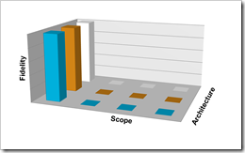

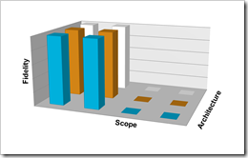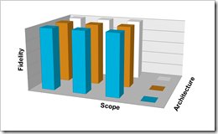

**Iterative**

The purely iterative approach builds all the features, across all components, to the lowest fidelity, and then increases the fidelity to the highest level.

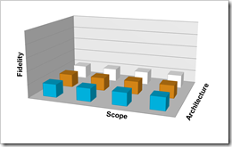 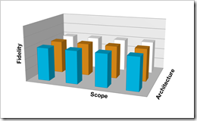 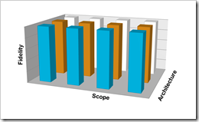

**Agile**

An Agile approach combines the incremental and iterative approach by building each feature, one by one, at a low fidelity, and then both gradually adding features *and* increasing their fidelity until the right combination is achieved. Full fidelity is not always necessary.

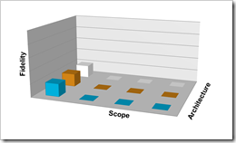 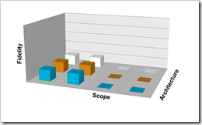 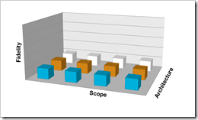 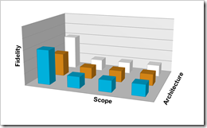 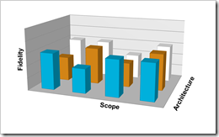 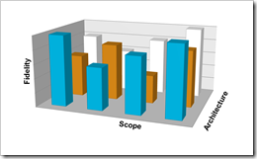

It is by adding the Fidelity dimension into the mix that Agile projects can achieve the flexibility required to deal with typical scenarios where scope, cost and time become fixed, without resorting to cutting on quality. Fidelity provides a mechanism to effectively vary scope, while still meeting all the customers needs and solving their problems.